Assignment sheet for IAM Assignment 1 :- Create an IAM user with username of your own wish and grant administrator policy.

Ans - 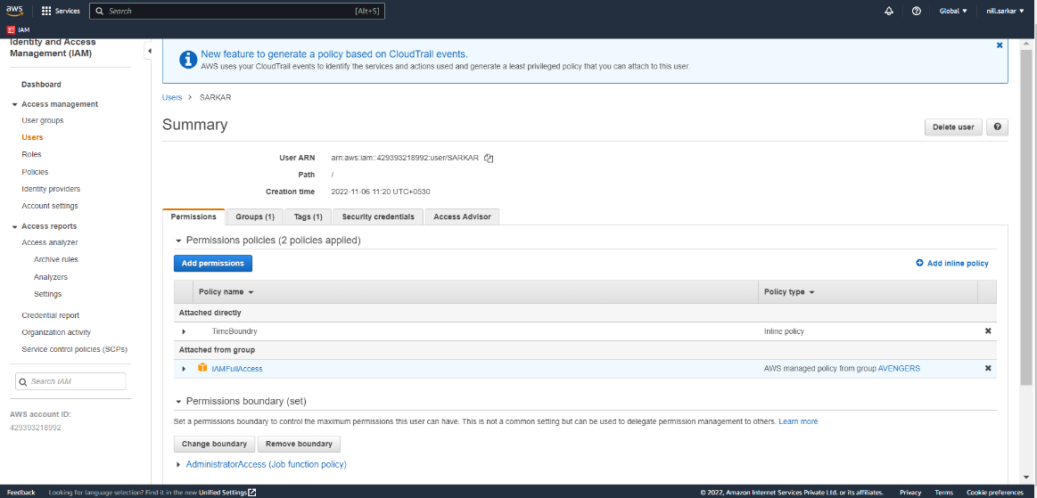

Assignment 2 :- Hello students, in this assignment you need to prepare a developers team of avengers.

Ans - 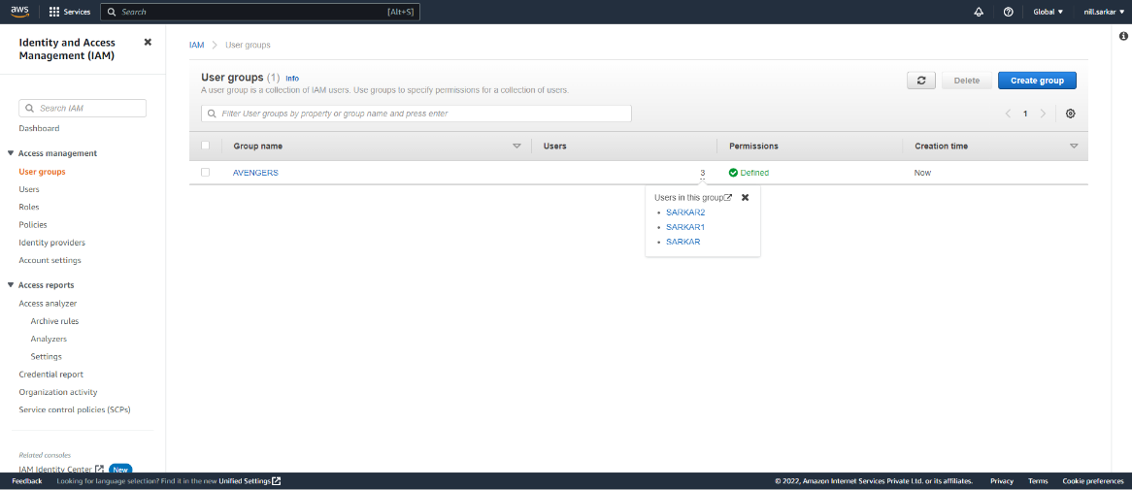

- Create 3 IAM users of avengers and assign them in developer’s groups with IAM policy.

Ans - 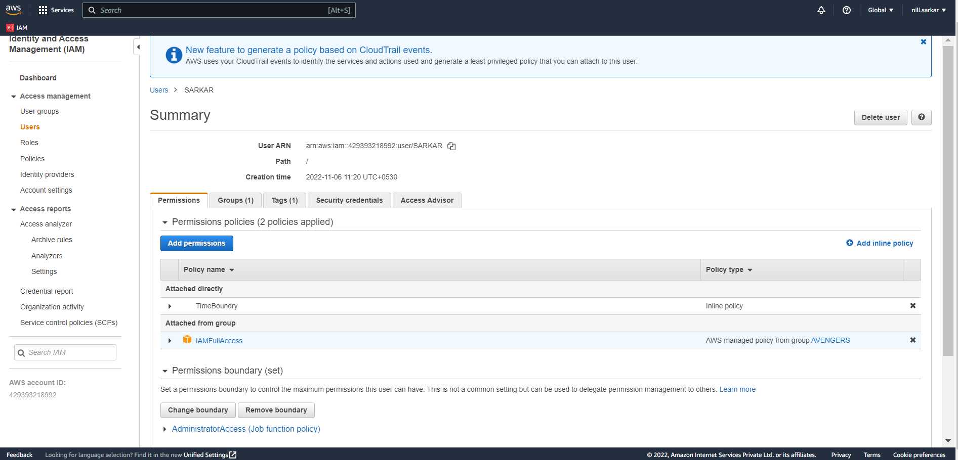

Assignment 3 :- Define a condition in policy for expiration like "DateGreaterThan": {"aws:CurrentTime": "2020-04-01T00:00:00Z"}, "DateLessThan": {"aws:CurrentTime": "2020-06-30T23:59:59Z"} Define the span of 4 months as per your wish

Ans -

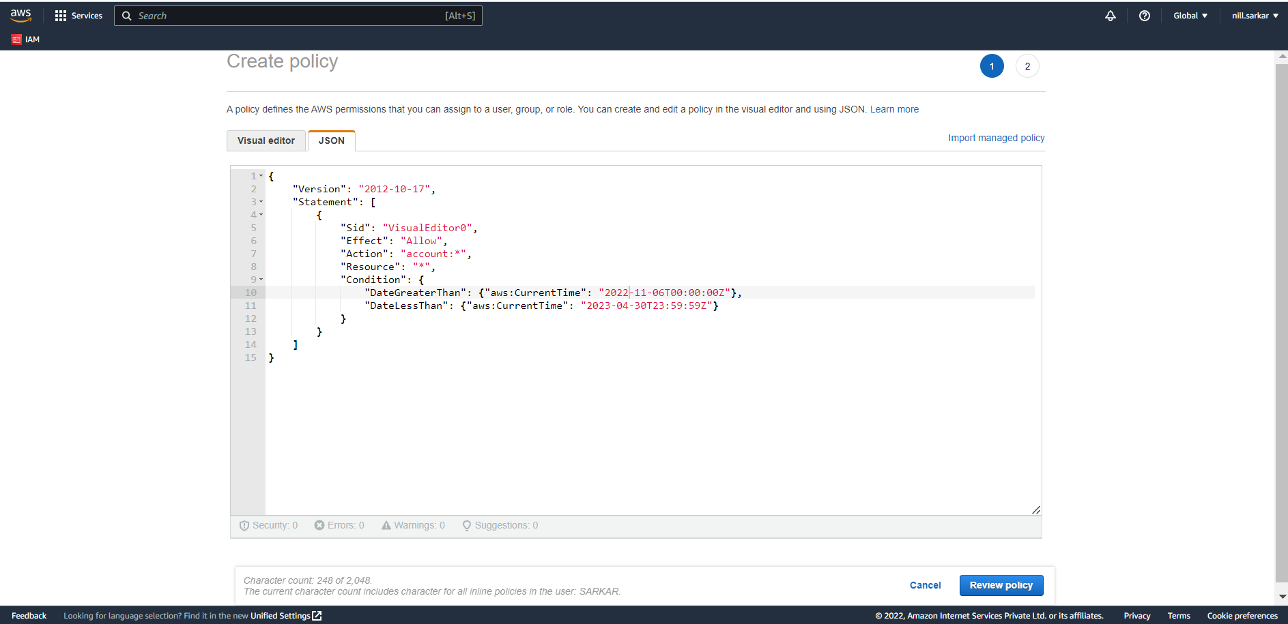

Assignment 3 :- Prepare 15 authentic MCQ questions related to IAM.

1. Which statement best describes IAM?  
     
   a. IAM stands for Improvised Application Management, and it allows you to deploy and manage applications in the AWS Cloud.  
     
   b. **IAM allows you to manage users, groups, roles, and their corresponding level of access to the AWS Platform.**  
     
   c. IAM allows you to manage users' passwords only. AWS staff must create new users for your organization. This is done by raising a ticket.  
     
   d. IAM allows you to manage permissions for AWS resources only.
2. You have created a new AWS account for your company, and you have also configured multi-factor authentication on the root account. You are about to create your new users. What strategy should you consider in order to ensure that there is good security on this account.  
     
   a. Require users to only be able to log in using biometric authentication.  
     
   b. Give all users the same password so that if they forget their password they can just ask their co-workers.  
     
   c. Restrict login to the corporate network only.  
     
   d. **Enact a strong password policy: user passwords must be changed every 45 days, with each password containing a combination of capital letters, lower case letters, numbers, and special symbols.**
3. Which of the following is not a component of IAM?  
     
   a. Roles  
   b. Users  
   c. **Organizational Units**  
   d. Groups
4. A new employee has just started work, and it is your job to give her administrator access to the AWS console. You have given her a user name, an access key ID, a secret access key, and you have generated a password for her. She is now able to log in to the AWS console, but she is unable to interact with any AWS services. What should you do next?  
     
   a. Ensure she is logging in to the AWS console from your corporate network and not the normal internet.  
     
   b**. Grant her Administrator access by adding her to the Administrators' group**.  
     
   c. Tell her to log out and try logging back in again.  
     
   d. Require multi-factor authentication for her user account.
5. Which of the following is not a feature of IAM?  
     
   a**. IAM allows you to setup biometric authentication, so that no passwords are required.**  
     
   b. IAM offers fine-grained access control to AWS resources.  
     
   c. IAM offers centralized control of your AWS account.  
     
   d. IAM integrates with existing active directory account allowing single sign-on.
6. When you create a new user, that user ________.  
     
   a**. Will be able to interact with AWS using their access key ID and secret access key using the API, CLI, or the AWS SDKs.**  
     
   b. Will be able to log in to the console only after multi-factor authentication is enabled on their account.  
     
   c. Will only be able to log in to the console in the region in which that user was created.  
     
   d. Will be able to log in to the console anywhere in the world, using their access key ID and secret access key.
7. Which of these is Identity in IAM?

|  |  |
| --- | --- |
| (a) | Users |
| (b) | Groups |
| (c) | Roles |
| (d) | **All of these**  8. When you first create an Amazon Web Services (AWS) account, you begin with a single sign-in identity that has complete access to all AWS services and resources in the account. This identity is called:   |  |  | | --- | --- | | (a) | **Root user** | | (b) | Main user | | (c) | Super user | | (d) | None of these   |  |  |  |  |  |  |  |  |  |  |  |  |  |  |  |  |  |  | | --- | --- | --- | --- | --- | --- | --- | --- | --- | --- | --- | --- | --- | --- | --- | --- | --- | --- | | 9. An IAM user:   |  |  | | --- | --- | | (a) | is an entity that you create in AWS | | (b) | is to give people the ability to sign in to the AWS Management Console for interactive tasks and to make programmatic requests to AWS services using the API or CLI | | (c) | **A and B both** | | (d) | None of these   |  |  |  |  |  |  |  |  |  | | --- | --- | --- | --- | --- | --- | --- | --- | --- | | 10. IAM group:   |  |  | | --- | --- | | (a) | Is same as IAM users | | (b) | **Can be used to specify permissions for a collection of users** | | (c) | Is truly an identity | | (d) | All of these | | | | |  |  | | --- | |  | |